**Hands-On Lab 1 – Accessing Data Using JPA (Standalone)**

### **Objective**

Build a standalone Java application using **JPA with Hibernate** to perform CRUD operations on a MySQL database — **without using Spring Boot**.

### **Requirements**

* Java 17+
* Maven
* MySQL Database
* IDE (IntelliJ / Eclipse / VS Code)
* Hibernate (via JPA)
* No Spring Framework

### **Project Structure**

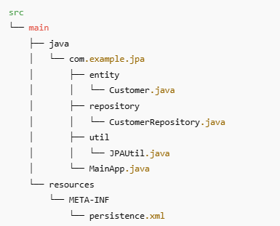

### **Dependencies (Add in pom.xml)**

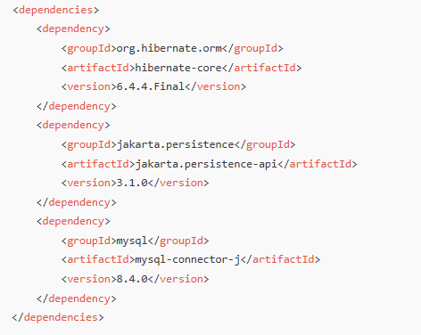

### **persistence.xml (under resources/META-INF)**

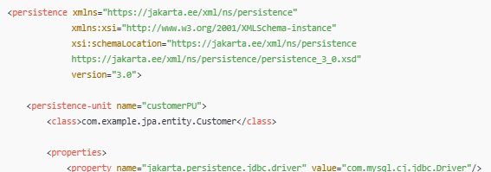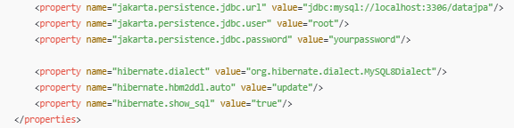

### **Entity Class – Customer.java**

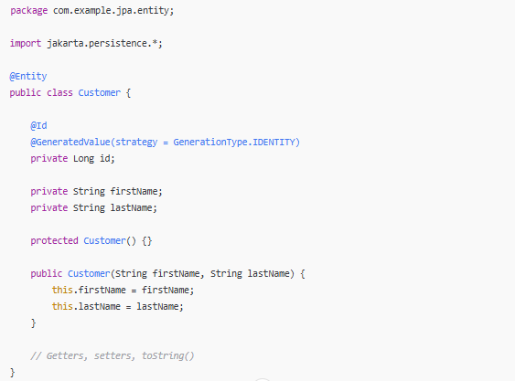

### **Utility – JPAUtil.java**

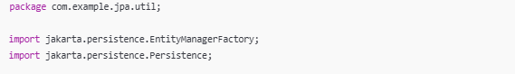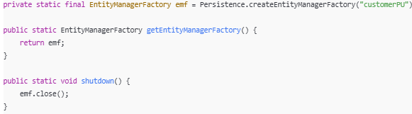

### **CustomerRepository.java**

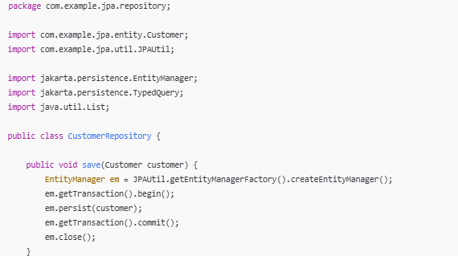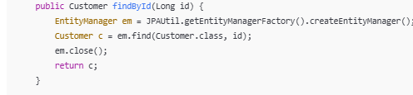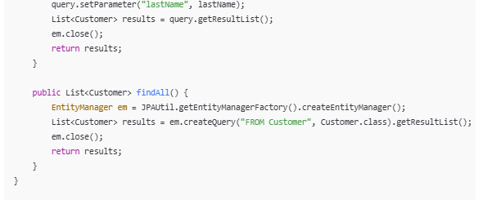

### **Main Class – MainApp.java**

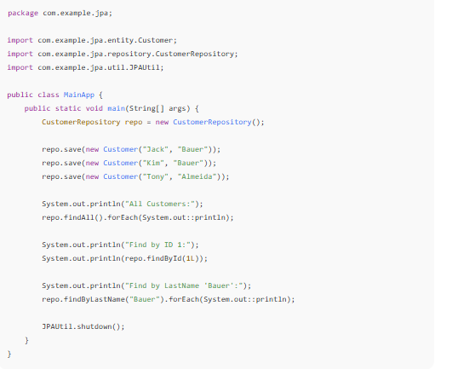

### **Homework Questions**

1. What does the @Entity annotation do?
2. How does JPA manage object persistence under the hood?
3. What would happen if you changed hibernate.hbm2ddl.auto to create?
4. How can you switch to PostgreSQL or H2 without touching Java code?
5. How would you enable pagination?